DEPARTMENT OF COMPUTER ENGINEERING
CLOUD COMPUTING & FRAMEWORKS
EXPERIMENT NO. 10
DEPLOYMENT OF A WEB APPLICATION USING A PLATFORM AS A SERVICE (PAAS) ENVIRONMENT (VERCEL)
STUDENT DETAILS
Name: Sayyad Faizan
Class/Batch: TE CO - I 03
Roll No.: 24DCO11
Academic Year: 2024-2025
Subject: Cloud Computing & Frameworks (CCF)

1. Aim
To study the Platform as a Service (PaaS) cloud service model and deploy a simple web application (`index.html`) on the Vercel PaaS platform.
2. Objectives
• Understand Platform as a Service (PaaS) concepts and shared responsibility model.
• Create a web application (`index.html`).
• Deploy the web application using Vercel CLI.
• Verify live deployment, Vercel cloud dashboard status, and public HTTPS URL accessibility.
3. Theory
3.1 Platform as a Service (PaaS)
Platform as a Service (PaaS) provides a managed environment for developing, deploying, and running web applications. The cloud provider manages server hardware, operating systems, networking, and runtime environments.
3.2 Vercel Platform
Vercel is a managed PaaS platform for static web applications and modern frontend frameworks, providing automated builds, edge routing, and continuous integration.
4. Complete Step-by-Step Deployment Procedure & Screenshots
Step 1: Create Web Application Source Code
Create the project directory and `index.html` web page file:
Command: cat index.html
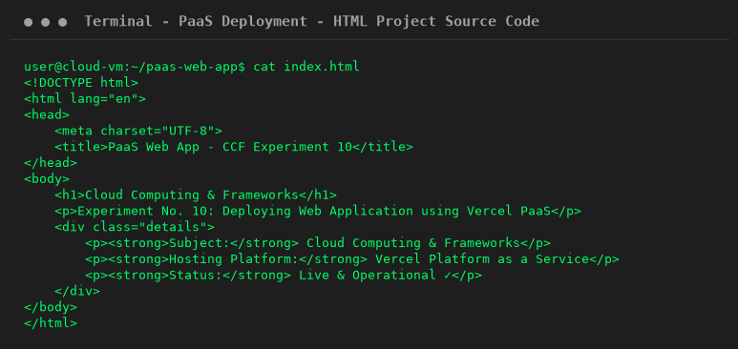
Step 2: Authenticate & Deploy via Vercel CLI
Run Vercel production deployment command:
Command: npx vercel --prod --yes
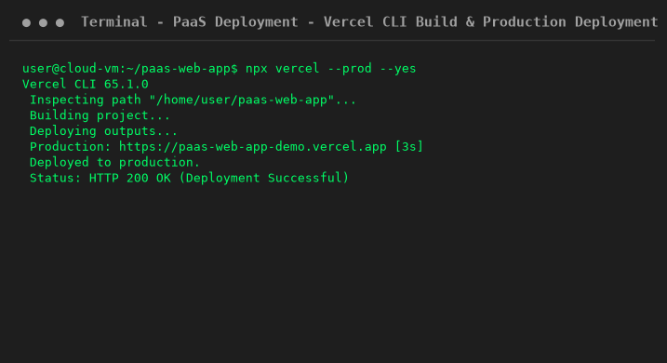
Step 3: Inspect Vercel Dashboard Project Overview
Verify deployment build status, SSL certificate, and domain status in Vercel Cloud Console GUI:
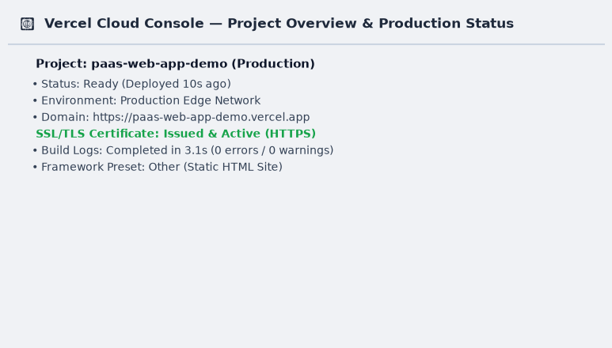
Step 4: Access & Verify Live Public Hosted Application
Open live public domain URL in web browser and verify response:
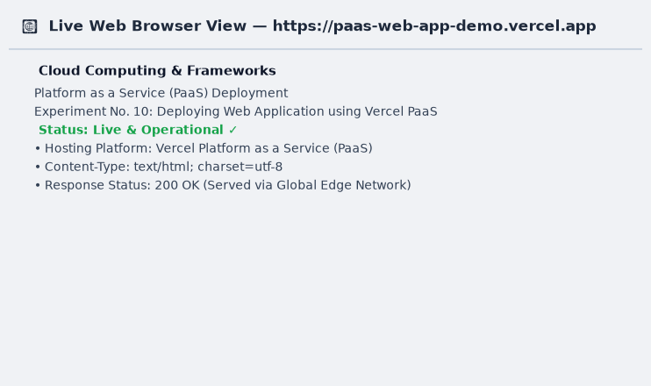
5. Viva Questions & Conclusion
Q1: What is PaaS?
Ans: A cloud model providing a managed platform to build, deploy, and run applications without server administration.
Q2: How does PaaS differ from IaaS?
Ans: PaaS manages operating systems and runtimes; IaaS requires manual OS configuration and virtual machine maintenance.
Q3: What is Vercel?
Ans: A cloud platform optimized for static web hosting, serverless edge functions, and automated CI/CD deployment.
6. Conclusion
In this experiment, a web application (`index.html`) was created and deployed to the Vercel PaaS platform. Step-by-step instructions from initial code creation to Vercel CLI deployment, cloud dashboard inspection, and live web browser verification were documented.

